Driving a motor… with 2 buttons!

# **Description**

This tutorial is a guide for driving a Vex IQ Smart Motor with the Vex IQ Controller buttons

# **Instructions**

1. Look on the desktop for the Robot C icon. Select the “RobotC for Vex Robotics”  
   Do not open the “Graphical ROBOTC” program  
   1. 
2. Open a new file and enter the following  
   1. 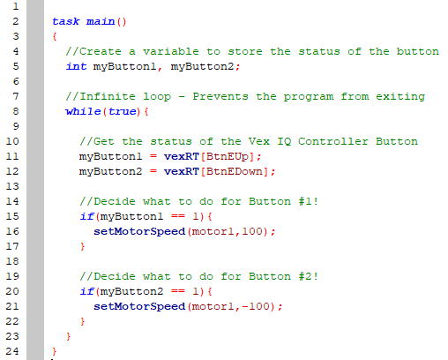
3. Compile, Download to Robot, and Start
   1.  🡪  🡪 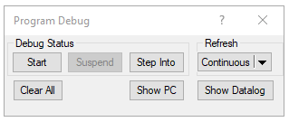
4. Notice, the motor never stops! Why?
5. Let’s try adding an **else statement** to **both buttons** to stop the motor. Enter the following code, then Compile, Download, and Start  
   1. 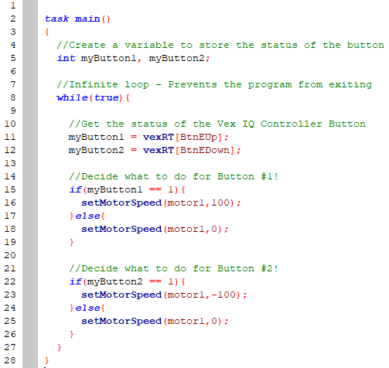
6. Notice, the motor stutters or never starts! Why?
   1. When we press Button E Up, E Down is **not** being pressed… so line 25 says: *stop the motor*
   2. When we press Button E Down, E Up is **not** being pressed… so line 18 says: *stop the motor*
   3. To fix this, we combine the if-statements as follows…  
        
      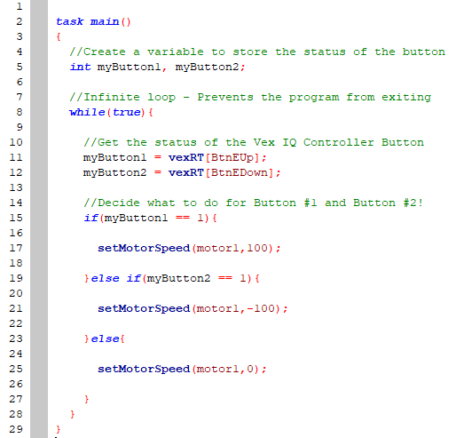
7. Change up the motor and speed!
   1. Try using a different speed (ex. “-100” or “25”)
8. Add another pair of buttons to control a different motor!
   1. Add two more global variable for two more buttons
   2. Fill the two added variables with another vexRT[] button
   3. Decide which motor to control with the added button
9. Use the following as a guide:

